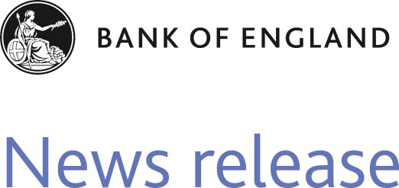Threadneedle Street London EC2R 8AH **T** 020 7601 4411

**F** 020 7601 5460

[press@bankofengland.co.uk](mailto:press@bankofengland.co.uk) [www.bankofengland.co.uk](http://www.bankofengland.co.uk/)

13 June 2011

**Why the Bank Rate should increase now - speech by Martin Weale**

In a speech at the Finance Directors’ Strategy Meeting in London, Martin Weale – External Member of the Monetary Policy Committee (MPC) – explains why he thinks that Bank Rate should rise earlier than currently expected by financial market participants, but not necessarily by as much over the next few years.

Martin Weale begins by arguing that the projections presented in the May Inflation Report give a clear message: “...for inflation to be brought back to target interest rates must be expected to rise”. The question is: when? He notes that there is a variety of alternative paths for interest rates that might bring inflation back to the 2% target in the medium term. And he goes on to explain why he thinks that an earlier rise in Bank Rate than currently expected by financial market participants would give the MPC greater flexibility in dealing with the outlook as it evolves. He says: “If inflationary pressures subsequently prove more severe than the central part of our forecast suggests, then it will be a help to have started to raise interest rates earlier. But if they prove less strong then subsequent increases can be slower than would otherwise be the case. Indeed, if the economy is extremely weak, interest rates can be reduced again.” He adds that, were the MPC to raise Bank Rate now, it is possible that interest rates further in the future will be lower than currently expected. What an early rate rise would do, he argues, “...is reduce the speculation that the Bank has departed from its inflation mandate. This itself will reduce the subsequent risks and may, indeed, mean that, averaged over the next three years, monetary policy does not need to be as tight as the current yield curve suggests.”

Regarding recent economic developments, Martin Weale notes the recent succession of weak output indicators, although he points out the latest ‘hard data’ from the ONS suggest that industrial production declined in April by less than might have been expected given the extra bank holiday. He goes on to argue that, in assessing the state of the global economy, not enough attention may have been paid to developments in our near neighbours, noting that the German unemployment rate has fallen to its lowest level since reunification. On the other hand, he points out, as in the United States, there are signs that German growth may have slowed into the second quarter.

Martin Weale notes that in the United Kingdom “...there is still a substantial risk that the headline inflation rate will rise above 5 per cent per annum later this year.” And despite being pleasantly surprised by the

“...substantial cost pressures in the economy”. In sum, despite slightly weaker economic growth in the near term than might be hoped for, Martin Weale concludes that the case for an early rise in Bank Rate remains.

# Key Resources

[**Why the Bank Rate should increase now – Full speech**](http://www.bankofengland.co.uk/archive/Documents/historicpubs/speeches/2011/speech503.pdf)